Degree Adjunct

✅ What Is a Degree Adjunct?
# Source: AI Source: Provided by: [Data Path: Persons Table -> ID Column: 1, Name_En Column: Motasem Essam] -> From: [Chatgpt (GPT-4-turbo)] on [8/6/2025]
A degree adjunct expresses how much, to what extent, or how intensely something happens, is true, or is described. It modifies adjectives, verbs, or other adverbs to indicate intensity, amount, or extent.
It answers questions like:
- How much?
- To what degree?
- How intensely?

🔸 Common Forms of Degree Adjuncts:
# Source: AI Source: Provided by: [Data Path: Persons Table -> ID Column: 1, Name_En Column: Motasem Essam] -> From: [Chatgpt (GPT-4-turbo)] on [8/6/2025]
- Adverbs of Degree: very, too, quite, almost, nearly, enough, extremely, hardly, so, just
- Phrases and Clauses: to a great extent, as much as, so much that

🔸 Examples of Degree Adjuncts in Sentences:
# Source: AI Source: Provided by: [Data Path: Persons Table -> ID Column: 1, Name_En Column: Motasem Essam] -> From: [Chatgpt (GPT-4-turbo)] on [8/6/2025]
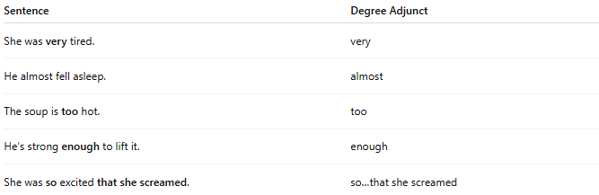
Sentence | Degree Adjunct
She was very tired. | very
He almost fell asleep. | almost
The soup is too hot. | too
He’s strong enough to lift it. | enough
She was so excited that she screamed. | so…that she screamed

🔸 Position in the Sentence:
# Source: AI Source: Provided by: [Data Path: Persons Table -> ID Column: 1, Name_En Column: Motasem Essam] -> From: [Chatgpt (GPT-4-turbo)] on [8/6/2025]
- Before adjectives/adverbs: He was extremely happy.
- Before verbs (less common): She just missed the bus.
- After adjectives (for “enough”): It’s big enough.

🔸 Reminder:
# Source: AI Source: Provided by: [Data Path: Persons Table -> ID Column: 1, Name_En Column: Motasem Essam] -> From: [Chatgpt (GPT-4-turbo)] on [8/6/2025]
A degree adjunct enhances meaning by showing intensity or scope, but it is not essential to grammatical structure.
🟢 "She was tired."
🟡 "She was very tired." → Degree adjunct intensifies the description

